# Lab: Text Processing

Problems for exercises and homework for the ["Programming Fundamentals" course @ SoftUni](https://softuni.bg/courses/programming-fundamentals)

You can check your solutions in [Judge.](https://judge.softuni.bg/Contests/1669/Text-Processing-Lab)

## Reverse Strings

You will be given series of strings until you receive an **"end"** command. Write a program that reverses strings and printseach pair on separate line in format **"{word} = {reversed word}"**.

### Examples

|  |  |
| --- | --- |
| **Input** | **Output** |
| helLo  Softuni  bottle  end | helLo = oLleh  Softuni = inutfoS  bottle = elttob |
| Dog  caT  chAir  end | Dog = goD  caT = Tac  chAir = riAhc |

### Solution

Use while loop and read strings until you receive **"end"**.

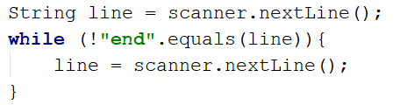

Reverse the string with for loop. Start from the last index and append each symbol to the new string.

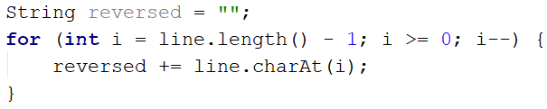

Print the reversed string in the specified format.



### Repeat Strings

### Write a Program That Reads an Array of Strings. Each String is Repeated N Times, Where N is the Length of the String. Print the Concatenated String.

### Examples

|  |  |
| --- | --- |
| **Input** | **Output** |
| hi abc add | hihiabcabcabcaddaddadd |
| work | workworkworkwork |
| ball | ballballballball |

### Solution

Read a string array.



Initialize StringBuilder.



Iterate through elements in the array. Find the length of the word at each iteration and append it to the StringBuilder.

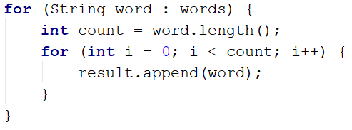

Print the StringBuilder.

## Substring

On the first line you will receive a string. On the second line you will receive a second string. Write a program that removes all of the occurrences of the first string in the second until there is no match. At the end print the remaining string.

### Examples

|  |  |  |
| --- | --- | --- |
| **Input** | **Output** | **Comment** |
| ice  kicegiciceeb | kgb | We remove ice once and we get "kgiciceeb"  We match "ice" one more time and we get "kgiceb"  There is one more match. The finam result is "kgb" |

### Hints

* Read the input.
* Find the first index where the key appears.
  + Use the built-in method indexOf()
* Remove the match.
  + Use the built-in method replace(String oldValue, String newValue)
* Repeat it until the text doesn't contain the key anymore.

## Text Filter

Write a program that takes a **text** and a **string of banned words**. All words included in the ban list should be replaced with **asterisks** "**\***", equal to the word's length. The entries in the ban list will be separated by a **comma** and **space** "**,** ".

The ban list should be entered on the first input line and the text on the second input line.

### Examples

|  |  |
| --- | --- |
| **Input** | **Output** |
| Linux, Windows  It is not **Linux**, it is GNU/**Linux**. **Linux** is merely the kernel, while GNU adds the functionality. Therefore we owe it to them by calling the OS GNU/**Linux**! Sincerely, a **Windows** client | It is not *****, it is GNU/*****. ***** is merely the kernel, while GNU adds the functionality. Therefore we owe it to them by calling the OS GNU/*****! Sincerely, a ******* client |

### Hints

* Read the input.
* Replace all ban words in the text with asterisk (*).
  + Use the built-in method replace(banWord, replacement).

## Digits, Letters and Other

Write a program that receives a single string and on the first line prints all the digits, on the second – all the letters, and on the third – all the other characters. There will always be at least one digit, one letter and one other characters.

### Examples

|  |  |
| --- | --- |
| **Input** | **Output** |
| Agd#53Dfg^&4F53 | 53453  AgdDfgF  #^& |

### Hints

* Read the input.
* Use loop to iterate through all characters in the text. If the char is digit print it, otherwise ignore it.
  + Use Character.isDigit(char symbol)
* Do the same for the letters and other chars
  + Find something like isDigit method for the letters.